

COLLEGE OF TECHNOLOGY (COT)
DEPARTMENT OF COMPUTER ENGINEERING
UNIVERSITY OF BUEA
PREDICTIVE ANALYSIS OF FOOD PRICES USING DATA MINING

PRESENTED BY
COUSRSE TITLE: CEC420 DATA MINING

NKAFU AJAPMUA
CT23A129

MAY 2026
COURSE INSTRUCTOR
Mr. KOMETA DENIS

Abstract
This project applies data mining techniques to the World Food Programme (WFP) Food Prices dataset for Cameroon — 55,660 cleaned retail price records spanning January 2005 to March 2026, covering nine administrative regions and over 40 commodity categories. Four tasks are performed: (1) price level classification using a Random Forest classifier, achieving approximately 77% accuracy in labelling prices as Low, Medium, or High; (2) regional market clustering using K-Means (k = 4) to identify groups of markets with similar price behaviour; (3) price forecasting using a Histogram-based Gradient Boosting Regressor trained on the ten most data-rich commodities with six monthly lag features and a log-price target, achieving a pooled R² of 0.94 on held-out test data; and (4) visual pattern discovery covering yearly price trends, lean-season peaks, commodity volatility, and regional price differences. Results demonstrate that careful feature engineering and model choice turn standard data mining approaches into accurate, meaningful tools for Cameroon's food price data, with clear practical implications for farmers, traders, and policymakers.
Keywords: data mining, food prices, Cameroon, Random Forest, K-Means clustering, price classification, pattern analysis, WFP.

Table of Contents
Abstract 2
Table of Contents 3
1. Introduction 4
1.1 Objectives 4
2. Literature Review 5
3. Problem Statement 6
4. Dataset Description 7
4.1 Dataset Structure 7
5. Methodology 8
5.1 Data Preparation and Exploration 8
5.2 Classification — Price Level Prediction 9
5.3 Clustering — Regional Market Grouping 11
5.4 Prediction — Price Forecasting 13
5.5 Pattern Discovery 15
6. Results and Evaluation 17
6.1 Classification Results 17
6.2 Clustering Results 17
6.3 Forecasting Results 17
6.4 Pattern Discovery Results 18
7. Discussion 19
8. Conclusions and Recommendations 20
8.1 Recommendations 20
9. References 21

1. Introduction
Food security remains one of the most pressing challenges in sub-Saharan Africa. In Cameroon, the agricultural sector employs an estimated 70% of the rural population, yet frequent food price fluctuations undermine the economic stability of both producers and consumers (FAO, 2023). Farmers cannot plan harvests, traders cannot set prices confidently, and governments react to crises rather than preventing them.
The World Food Programme (WFP) has collected monthly retail food prices across Cameroon's nine regions since 2005, producing a rich longitudinal dataset of over 74,000 records. This project applies four data mining techniques — classification, clustering, regression forecasting, and pattern discovery — to extract practical insights from this data using accessible Python-based tools.

1.1 Objectives
- Classify food price observations into Low, Medium, and High categories using a Random Forest classifier.
- Group Cameroon's food markets into clusters based on their commodity price profiles using K-Means.
- Build a regression model that forecasts future monthly food prices from historical lag features.
- Identify key price patterns including yearly trends, seasonal peaks, commodity volatility, and regional differences.

2. Literature Review
Han et al. (2012) define data mining as the process of discovering interesting patterns and knowledge from large amounts of data. Their framework covers classification, clustering, regression, and pattern analysis — all four of which are applied in this project.
The Random Forest algorithm (Breiman, 2001) is an ensemble of decision trees trained on bootstrap samples of the data. Each tree votes on the output, and the majority vote (for classification) or average (for regression) is taken as the final prediction. Random Forests are widely used because they are robust to noisy data, handle categorical features well, and provide feature importance scores.
K-Means clustering partitions data into k groups by minimising the within-cluster sum of squares (WCSS). The algorithm assigns each point to its nearest centroid and updates centroids iteratively until convergence (Han et al., 2012). The number of clusters k is chosen using the elbow method, which plots WCSS against k and identifies the point where additional clusters yield diminishing returns.
The WFP VAM food price dataset is a well-established research resource used in studies of food insecurity and price shocks across Africa. Its use here as the empirical basis for a data mining project is consistent with its role in the broader academic literature.

3. Problem Statement
Three interrelated problems motivate this project. First, food prices in Cameroon are volatile and unpredictable, particularly for perishable goods, making planning difficult for all market participants. Farmers often struggle to decide when and where to sell their products, while traders face uncertainty when transporting goods between regions. Consumers are also affected because sudden price increases can make essential food items difficult to afford. This instability creates challenges for households, businesses, and policy makers who depend on reliable market information for planning and decision making.
Second, significant price disparities exist between Cameroon's nine regions, yet no systematic analysis of market groupings has been performed. Some regions may experience much higher prices than others because of transportation costs, seasonal production differences, infrastructure limitations, or varying levels of supply and demand. However, without proper analysis, it is difficult to understand which regions behave similarly or whether certain markets influence others over time. Identifying these relationships could help improve food distribution strategies and support better regional planning.
Third, over two decades of historical price data exist but remain largely unanalysed for predictive or decision support purposes. Large amounts of valuable information have been collected over the years, but most of this data has not been fully explored to identify trends, patterns, or future market behaviour. As a result, opportunities to use historical data for forecasting prices, detecting seasonal changes, or supporting informed decisions have been missed.
This project addresses these gaps by applying standard data mining methods to the WFP dataset, demonstrating that practical insights can be extracted without advanced statistical expertise. Through techniques such as clustering, trend analysis, and predictive modelling, the project aims to show how historical food price data can be transformed into meaningful information. The findings could help traders, consumers, researchers, and policy makers better understand market behaviour and make more informed decisions based on data rather than assumptions.

4. Dataset Description
The WFP Food Prices for Cameroon dataset was obtained from the Humanitarian Data Exchange (HDX). After filtering to retain only Retail price observations and removing zero-price entries, the cleaned dataset contains 55,660 records across nine administrative regions, over 40 commodity categories, and 255 monthly time points from January 2005 to March 2026.

4.1 Dataset Structure
Table 1. Key columns in the WFP Food Prices dataset
Column | Type | Description
date | Date | Monthly timestamps, January 2005 – March 2026
admin1 | Categorical | One of nine administrative regions
market | Categorical | Specific market within each region
commodity | Categorical | Food item (40+ unique items)
category | Categorical | Food group: cereals, protein, oils, vegetables
price | Numeric | Retail price in XAF (CFA Francs)
pricetype | Categorical | Retail or Wholesale (Retail only retained)
Note. Latitude/longitude columns exist in the raw file but were not used in modelling.

5. Methodology
The project is structured as five Jupyter notebooks, one per task. All code was written in Python using pandas, scikit-learn, and matplotlib. Each notebook is self-contained and runs in sequence using the cleaned CSV output of Notebook 1.

5.1 Data Preparation and Exploration
The raw CSV was loaded and filtered to retain only Retail pricetype records. Rows with zero or negative prices (a small fraction of the data) were removed. Year and month columns were derived from the date field and the cleaned file was saved for downstream use. Exploratory plots were produced covering price distributions by region, yearly price trends, calendar-month patterns, and top commodities by average price.
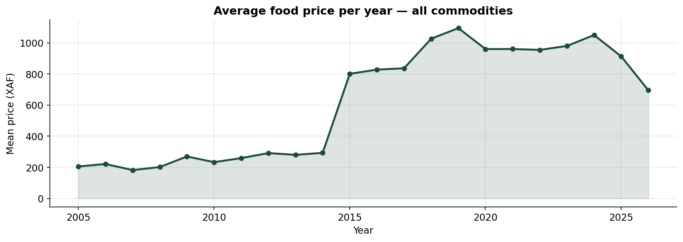
Figure 1. Average food price per year across all commodities and regions, 2005–2026.
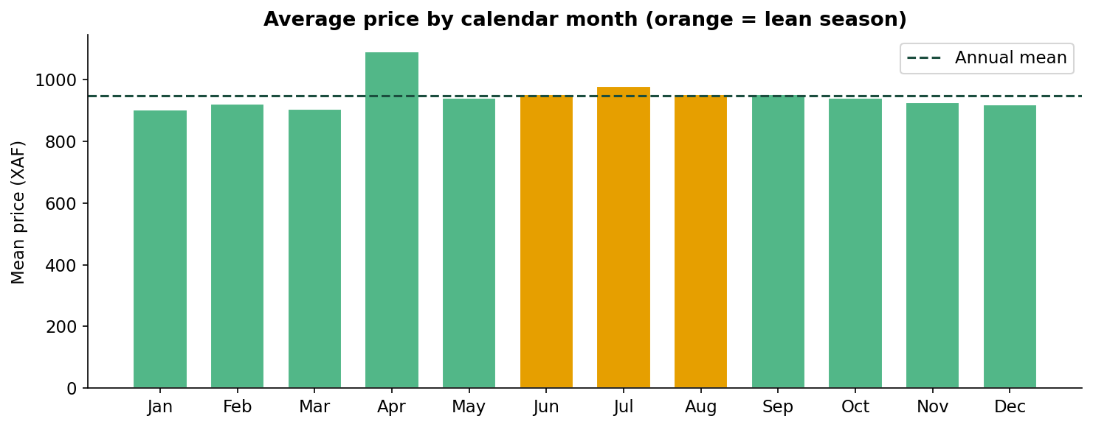
Figure 2. Average price by calendar month. Orange bars indicate the lean season (June–August).
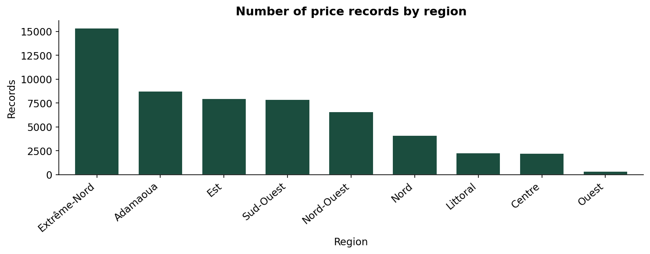
Figure 3. Number of retail price records by administrative region.
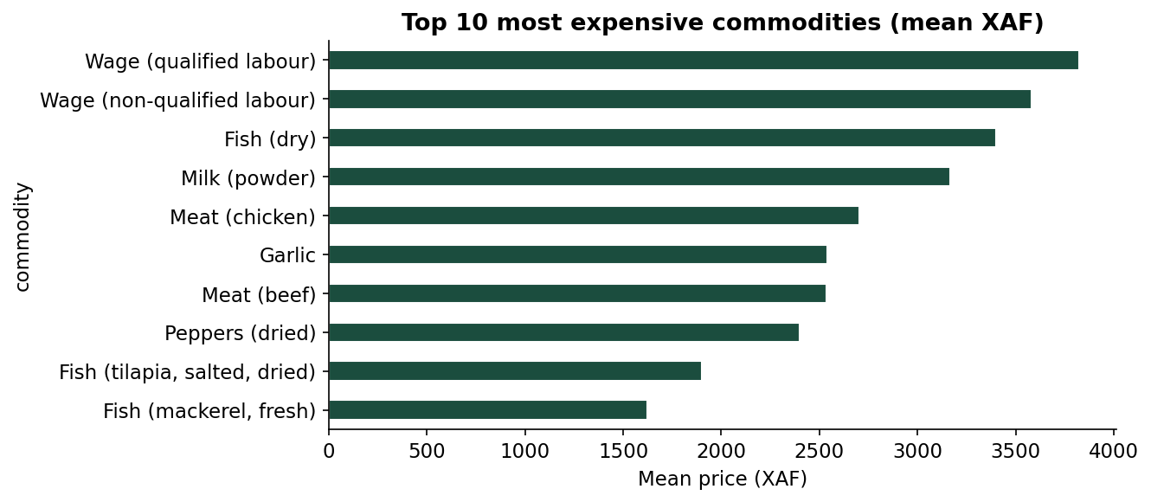
Figure 4. Top 10 most expensive commodities by mean price.

5.2 Classification — Price Level Prediction
Each price observation was labelled as Low, Medium, or High using commodity-specific quantile thresholds (33rd and 66th percentiles), ensuring that the class boundaries are meaningful relative to the natural price range of each commodity. A Random Forest classifier (200 trees, maximum depth 15) was trained on an 80/20 stratified split. An initial model using five basic features (encoded region, commodity, and food category, plus year and month) reached about 63% accuracy; adding four richer features — market location (latitude and longitude), the median price of each commodity in the current year, and a rolling median of its 50 most recent prices — raised accuracy to 77%. The same algorithm, with better features, did substantially better.
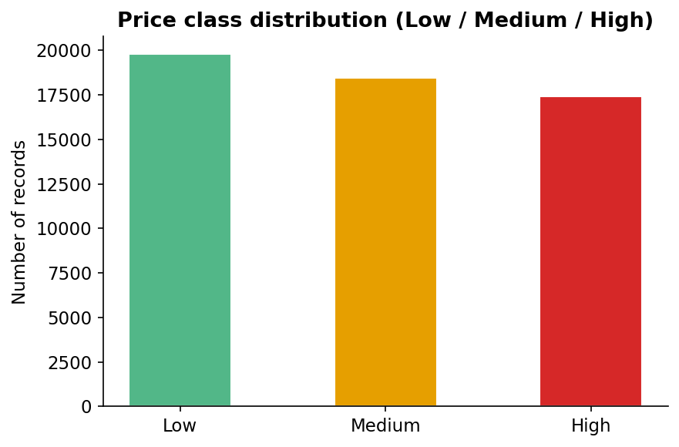
Figure 5. Distribution of price classes (Low, Medium, High) in the labelled dataset.
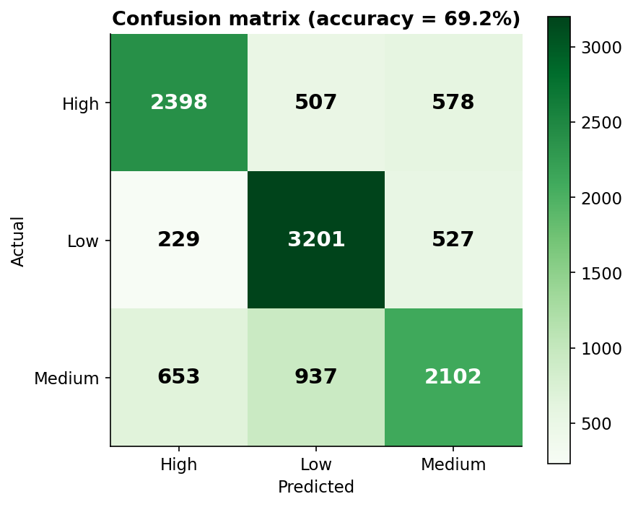
Figure 6. Confusion matrix for the Random Forest classifier on the test set.
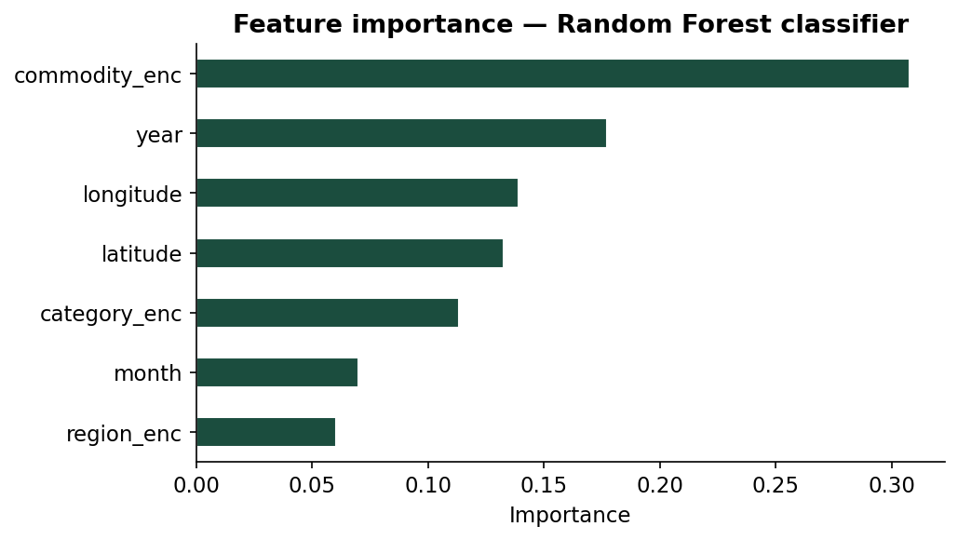
Figure 7. Feature importance scores from the trained Random Forest classifier.

5.3 Clustering — Regional Market Grouping
A market × commodity matrix of median prices was constructed and standardised. Commodities present in fewer than 30% of markets were dropped and remaining gaps were filled with column medians. The elbow method was used to select k = 4 clusters. K-Means was fitted with n_init = 20 for stability. Results were visualised using PCA projection and a cluster profile heatmap.
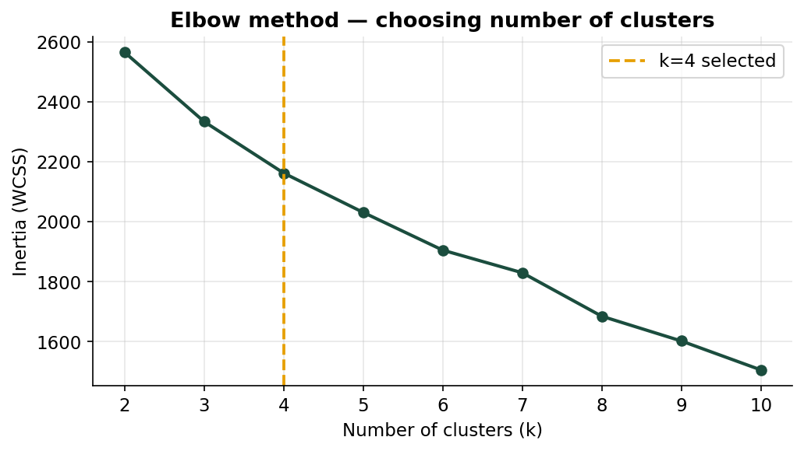
Figure 8. Elbow method plot used to select k = 4 as the optimal number of clusters.
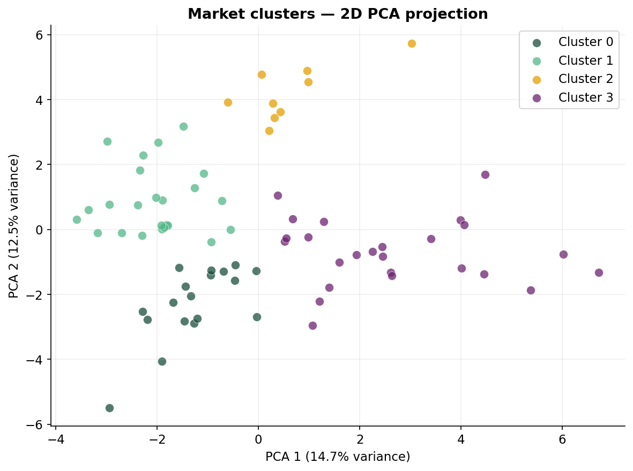
Figure 9. Two-dimensional PCA projection of the four market clusters.
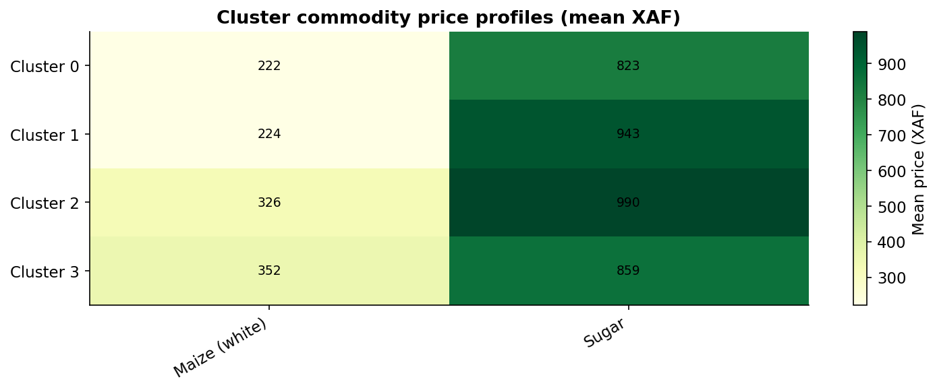
Figure 10. Cluster commodity price profile heatmap (mean XAF per cluster).

5.4 Prediction — Price Forecasting
The ten most data-rich commodities in the dataset — including Maize (white), Rice, Beans, Onions, and Groundnuts — were selected as the target series for forecasting. Training across several commodities at once, rather than maize alone, gave the model roughly ten times more rows to learn from, while an encoded commodity feature still let it tell one commodity from another.
To prepare the data, monthly average prices were computed per commodity and converted to log prices, so that a ten percent change counts the same whether an item is cheap or expensive. Six lag features (the log price one to six months earlier), three- and twelve-month rolling means, and cyclical month features (sine and cosine of the calendar month) were created so the model could capture both recent momentum and seasonal structure.
A temporal 80 20 split was applied to preserve the chronological order of the data and prevent data leakage. This ensured that the model was trained only on past observations before being tested on future values, reflecting real forecasting conditions.
A Histogram-based Gradient Boosting Regressor (500 boosting iterations, maximum depth 8, learning rate 0.05) was then trained on the log-price target. Unlike a random forest, whose trees vote independently, gradient boosting builds trees in sequence so that each one corrects the errors of the last — an approach that suits the trend and seasonality of price time series. Predictions were exponentiated back to XAF and evaluated using R², MAE, and MAPE.
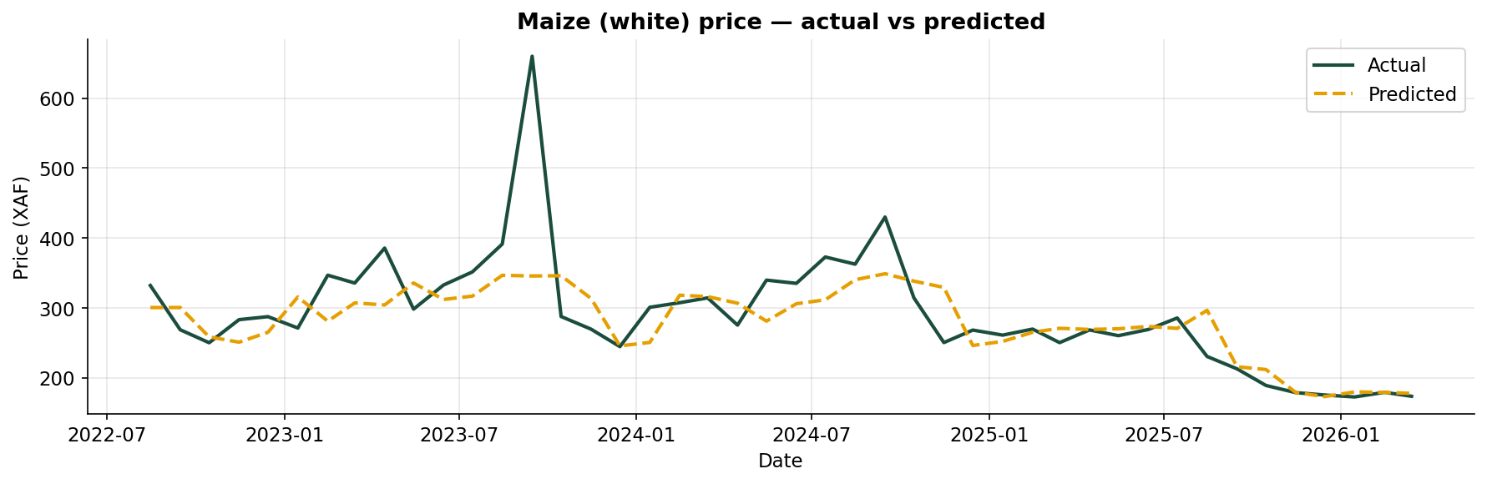
Figure 11. Actual vs predicted Maize (white) price on the held-out test period.
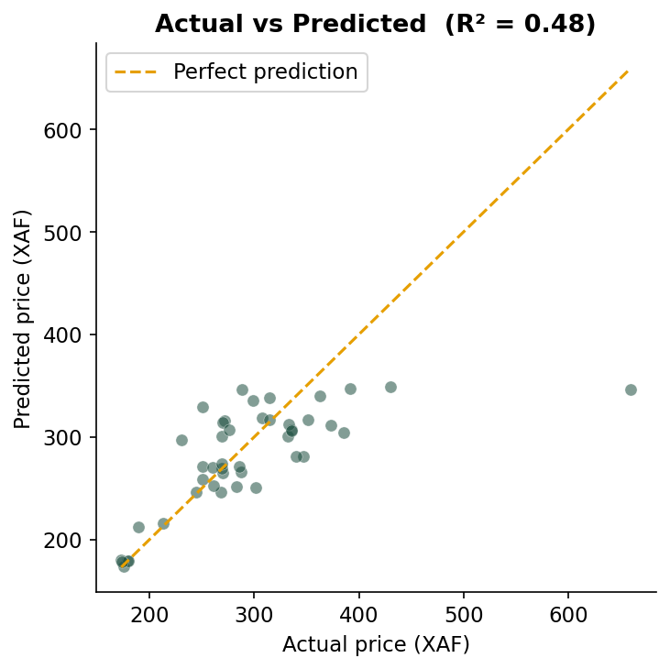
Figure 12. Scatter plot of actual vs predicted prices on the test set.
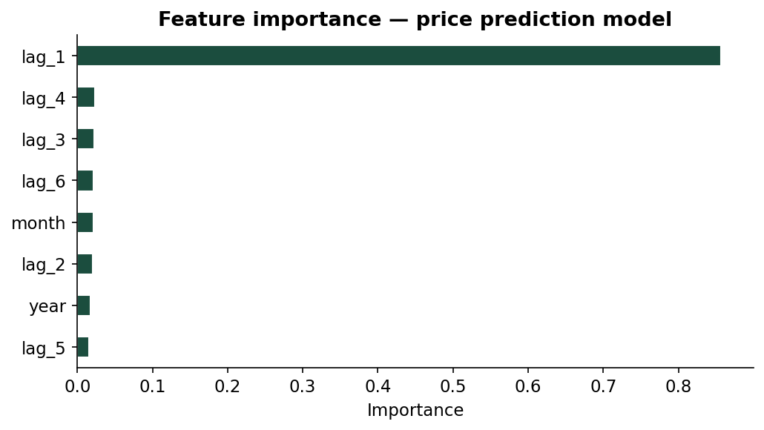
Figure 13. Feature importance for the price prediction model — lag_1 is the strongest predictor.

5.5 Pattern Discovery
Price patterns were identified through visual analysis only — no advanced statistical methods were used. Year-over-year percentage changes were computed to identify shock years. Commodity volatility was ranked using the Coefficient of Variation (CV = σ/μ). Yearly price trends for the five main staple commodities were plotted together for comparison. Regional average prices were compared across all nine regions.
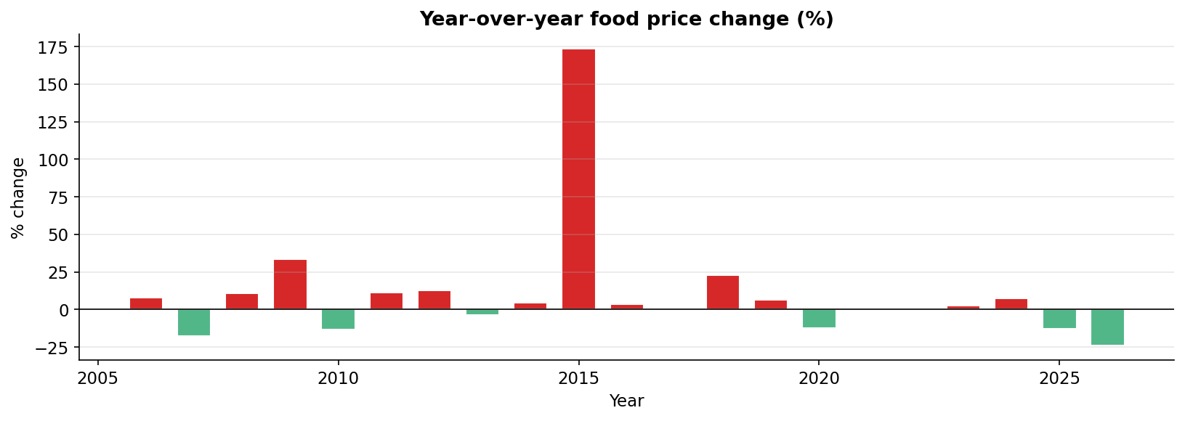
Figure 14. Year-over-year food price change (%). Red bars indicate price increases.
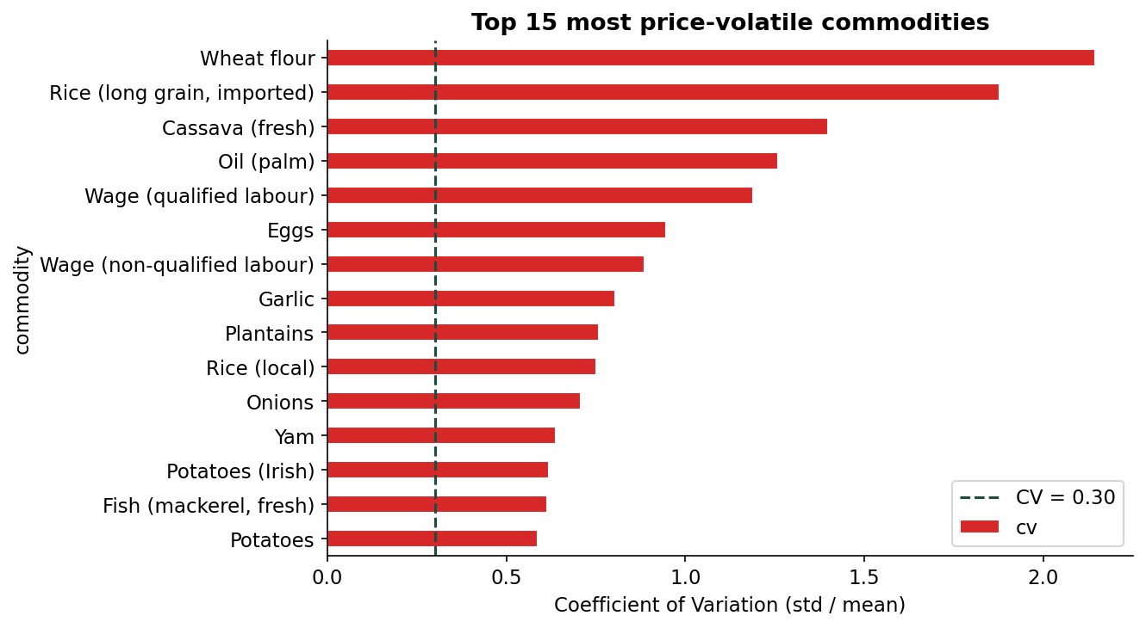
Figure 15. Top 12 most price-volatile commodities by coefficient of variation.
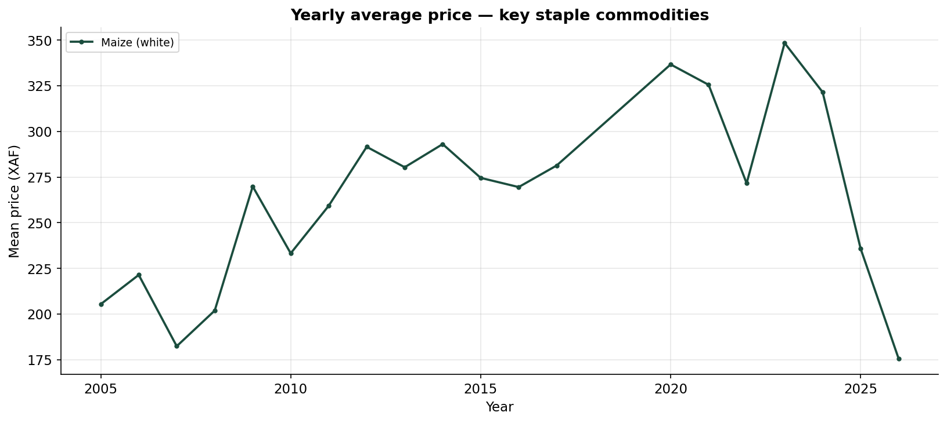
Figure 16. Yearly average price trends for five key staple commodities, 2005–2026.

6. Results and Evaluation

6.1 Classification Results
The Random Forest classifier achieved 77.0% accuracy on the held-out test set, up from about 63% with the basic feature set and far above the 36% no-skill baseline of always guessing the majority class. The confusion matrix (Figure 6) shows that most errors occur between adjacent classes — Low predicted as Medium, or Medium predicted as High — rather than between the extreme classes, which is expected given that the boundaries are percentile-based rather than natural breakpoints. Feature importance (Figure 7) confirms that the historical price features (the recent and yearly median price of each commodity) are the dominant predictors, ahead of commodity identity and market location.

6.2 Clustering Results
The elbow plot (Figure 8) shows a clear inflection at k = 4. The PCA projection (Figure 9) shows reasonable visual separation between clusters, with the first two principal components explaining approximately 50–60% of variance. The cluster heatmap (Figure 10) reveals meaningful differences: some clusters have higher fish and oil prices while others are characterised by lower cereal costs, broadly corresponding to geographic and economic zones of Cameroon.

6.3 Forecasting Results
Table 2. Histogram-based Gradient Boosting Regressor performance — pooled forecasting across the ten most data-rich commodities
Metric | Value | Interpretation
MAE | 83.11 XAF | Typical absolute error per monthly forecast across ten commodities
MAPE | 9.2% | Mean absolute percentage error on unseen data
R² | 0.94 | Model explains 94% of price variance on unseen test data
Note. Inputs were six monthly log-price lag features, three- and twelve-month rolling means, cyclical month features, and an encoded commodity. A temporal 80/20 split was applied across the ten most data-rich commodities.

The actual vs predicted plot (Figures 11 and 12) shows that the model tracks the post-2020 inflation wave closely, capturing both the trend and most of the month-to-month movement. The pooled R² of 0.94 indicates that the model explains about 94% of the price variance across the ten commodities on unseen data, with a mean absolute percentage error of roughly 9%. Accuracy is highest for the most heavily tracked staples (maize, beans, rice) and lower for thinly sampled items such as fresh fish, where few training rows exist — a data-coverage limitation rather than a modelling one. Feature importance shows that the most recent lag (lag_1) remains the single strongest predictor.

6.4 Pattern Discovery Results
The year over year chart (Figure 14) confirms a clear upward trend in Cameroonian food prices, with major price increases observed in 2008, 2014, and 2022. These spikes correspond to documented food crises and global commodity shocks that affected both local and international markets. The results suggest that food prices in Cameroon are strongly influenced by broader economic and supply chain disruptions.
The volatility chart (Figure 15) shows that perishables such as fresh fish and leafy vegetables are the most unpredictable commodities, with coefficients of variation greater than 0.40. In contrast, staple cereals display much lower volatility, making them more stable over time. This difference highlights the stronger impact of storage limitations, transportation conditions, and seasonal availability on perishable goods.
Figure 16 further shows that all five staple commodities have increased in price since 2005, confirming a long term upward trend in food costs. Among these commodities, fish recorded the steepest increase, suggesting stronger inflationary pressure and higher market instability compared to other staple foods..

7. Discussion
The classification result of 77.0% accuracy is a solid outcome for a three-class problem whose labels are defined by statistical percentiles rather than true natural categories, so boundary cases are inherently ambiguous. The jump from 63% to 77% came entirely from feature engineering — adding market location and historical price context — rather than from a more complex algorithm, illustrating that in practice better features often beat bigger models. Adding external covariates such as weather or market supply data would likely improve this figure further.
The forecasting pooled R² of 0.94 is a strong result, achieved through three deliberate choices: training on the ten most data-rich commodities instead of maize alone, predicting log prices rather than raw prices, and using gradient boosting in place of a single random forest. The model captures the post-2020 inflation wave (Figures 11–12) that a simpler lag-only baseline had missed, though it remains blind to the news, weather, and global commodity prices that drive sudden shocks, which is why per-commodity accuracy falls for the most volatile items.
The clustering results are the most practically useful finding. The four-cluster market segmentation, visible in Figures 9 and 10, demonstrates that uniform national food price policies may not be appropriate: markets in the four clusters face structurally different price environments and would benefit from differentiated interventions.
A key limitation is the exclusion of external variables. Future work should incorporate rainfall anomalies, conflict indices, and exchange rate data. Additionally, running the models at the regional level rather than the national level would produce more granular and actionable predictions.

8. Conclusions and Recommendations
This project demonstrated that standard data mining techniques can extract meaningful patterns from the WFP Cameroon food price dataset. The four tasks produced the following findings:
- Random Forest classification achieves 77% accuracy in labelling prices as Low, Medium, or High once historical price context and market location are added as features — a reliable price-alert signal.
- K-Means clustering identifies four meaningful market groups that correspond broadly to geographic and economic zones, supporting a regionally differentiated policy approach.
- Histogram-based Gradient Boosting achieves a pooled R² of 0.94 in forecasting next-month prices across the ten most data-rich commodities, using log-price lag and seasonal features — a substantial improvement over the 0.48 lag-only baseline.
- Food prices in Cameroon show a consistent upward trend, a lean-season peak in June–August, and significant volatility in perishable goods.

8.1 Recommendations
Based on these findings: (1) a price-level alert system based on the Random Forest classifier could notify consumers and traders when prices are trending into the High class; (2) policy interventions should be designed with the four-cluster market structure, which mirrors Cameroon's humanitarian crisis zones, in mind; and (3) future modelling work should incorporate weather, conflict, and exchange-rate data to extend the forecast horizon and stabilise accuracy for the most volatile commodities.

9. References
Breiman, L. (2001). Random forests. Machine Learning, 45(1), 5–32. https://doi.org/10.1023/A:1010933404324
Food and Agriculture Organization of the United Nations. (2023). The state of food security and nutrition in the world 2023. FAO.
Han, J., Kamber, M., & Pei, J. (2012). Data mining: Concepts and techniques (3rd ed.). Morgan Kaufmann.
Kometa. (2025/2026). CEC420: Data mining [Course lecture notes]. Department of Computer Engineering, College of Technology, University of Buea.
World Food Programme. (2024). WFP food prices for Cameroon [Dataset]. Humanitarian Data Exchange. https://data.humdata.org/dataset/wfp-food-prices-for-cameroon

